**Q.1 Introduction to UiPath in Robotic Process Automation (RPA) & Download.**

**Robotic Process Automation (RPA)** is a technology that allows you to automate repetitive tasks that humans usually do on computers — like filling out forms, copying data between apps, or generating reports. Think of it like a *digital worker* that does boring work for you!

**UiPath** is one of the most popular tools used in RPA.

It's a **no-code/low-code** platform, which means you don’t need to be a hardcore programmer to use it. You design automation by dragging and dropping activities, like building a flowchart.

**How to Download UiPath**

1. **Go to the official website:**

[https://www.uipath.com](https://www.uipath.com/)

1. **Sign Up:** 
   * Click on **"Start for Free"** or **"Get Community Edition"**.
   * Create a free account (or sign in with Google/Microsoft).
2. **Download UiPath Studio:** 
   * After logging in, navigate to the **Resource Center**. o Download **UiPath Studio** (the main tool where you create automations).
   * You’ll also have access to **UiPath Assistant** and **UiPath Orchestrator** (for managing bots remotely).
3. **Installation:** 
   * Run the installer. o Choose **"Community License"** (it’s free for learning and small businesses).
   * You can select **UiPath Studio** or **StudioX** (StudioX is even simpler, more business-user-friendly).

**Q2 UI BOT to display a Message.**

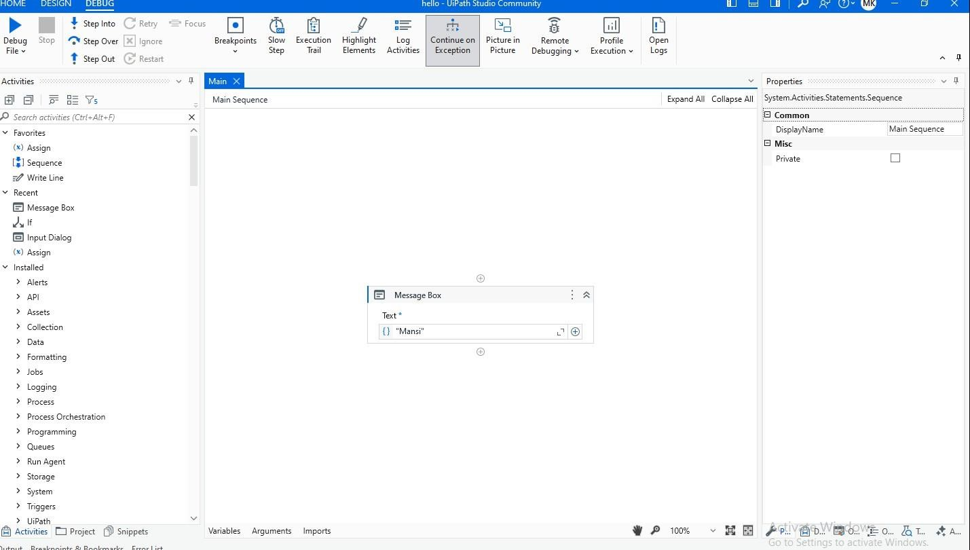

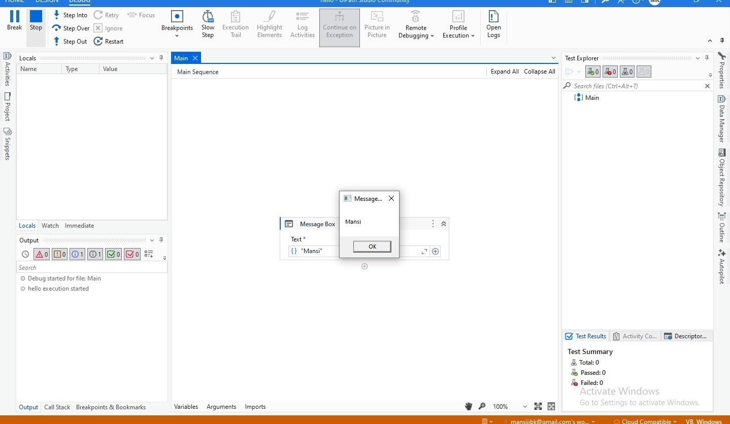

**Q3 UI BOT to demonstrate Control Flow.**

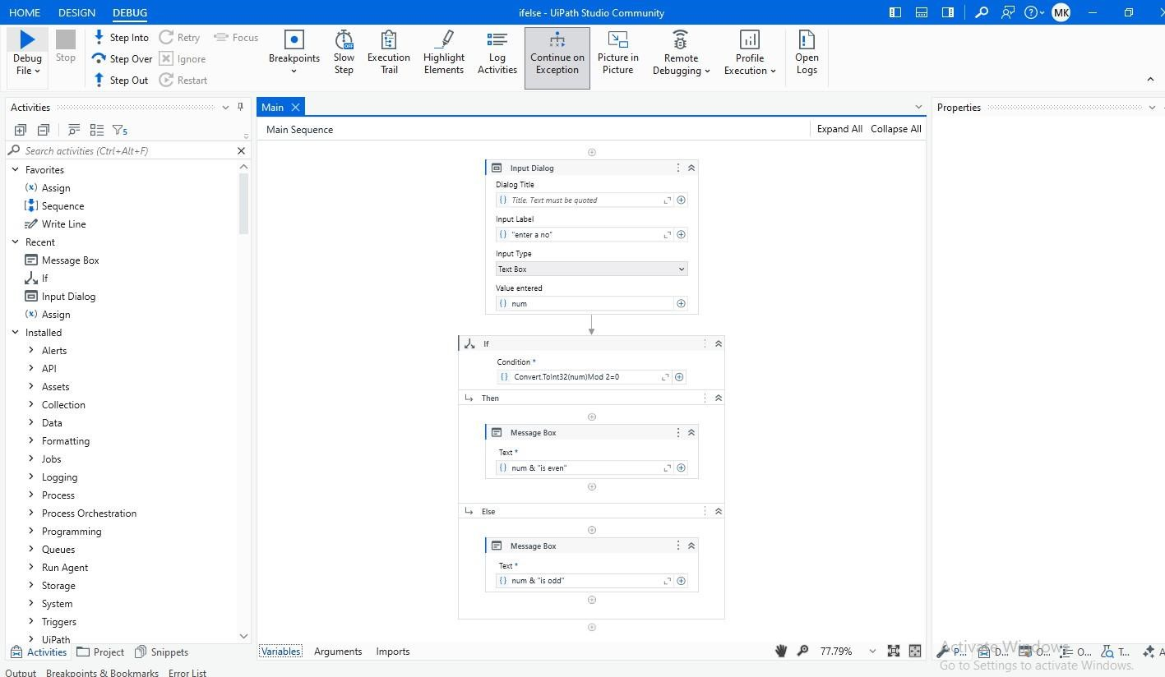

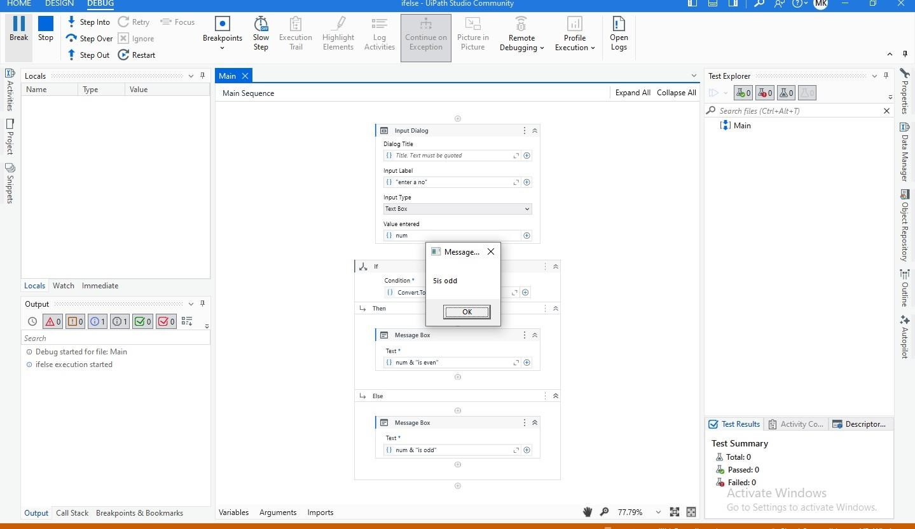

**Q4 UI BOT to demonstrate Error Handling**

